- Cacao trees grow in tropical areas such as South America, Asia, Africa, South Pacific Islands, Indonesia, and the Caribbean.
- Cacao trees flourish in wet, lowland areas in the shade of larger trees so they are sheltered from too much sunlight or wind.
- Farmers must let the trees grow for 3-5 years before they produce their first pods.
- Cacao trees are about 40 feet tall and have one-foot long leaves.
- The 50-70 pods produced on each of these trees each contain 25-50 seeds, which are called cocoa beans.
- Cacao harvesting is done by hand twice each year.
- After picking, the fruit is split open with a machete (big knife), and the beans are allowed to dry in shallow boxes for a week before shipping.

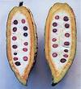
Pod after being opened.

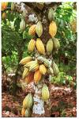
Pods hang from a Cacao tree.

