Dam Lesson: Salmon in the Columbia River System

Salmon: Running the Gauntlet

Gauntlet
a. A form of punishment or torture in which people armed with sticks or other weapons arrange themselves in two lines facing each other and beat the person forced to run between them.
b. The lines of people so arranged.
2. An onslaught or attack from all sides
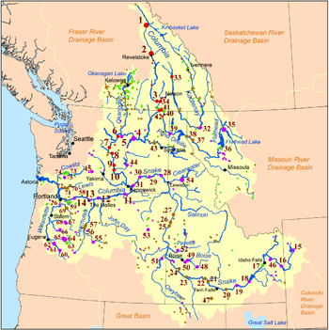
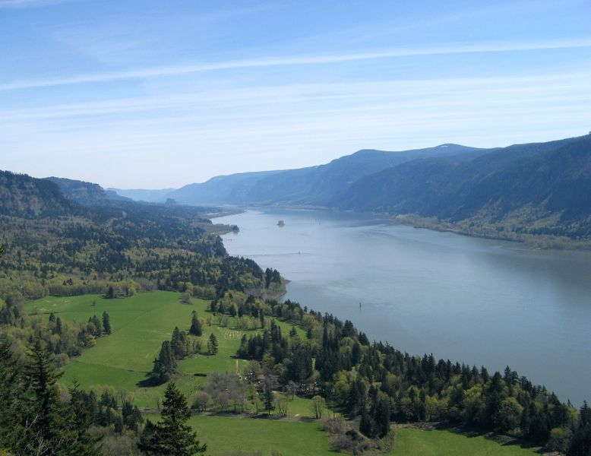
Prominent dams of the Columbia River Basin. Color indicates dam ownership:
U.S. Federal government
Public Utilities
State, provincial, or local government
Private

Between 1985 and 2007 an average of ____ sockeye salmon returned up the Columbia river system.

The region in which the Salmon live, spawn and die is referred to as the Pacific __________. Using the map below, which states are included in this region? Which Canadian province is also included?

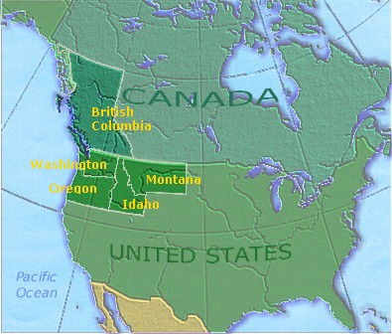

How often were there major salmon runs in the Columbia River basin? ______

Some Salmon in the Columbia river system are in the coastal ________________, while other live in the high desert canyons or the rugged __________ interior. This means in the mountains.

Salmon once spawned here in the ________ of thousands.

Bears eat salmon and then they “do what bears do in the woods”. Please explain how salmon provide nutrients to the river beds as well the surrounding area.

In the Columbia river basin there are small creeks. These creeks run together and become springs. This water does not contain very many nutrients; however, this water is pure enough to drink. Is this closer to the mouth or the source of the river? Where is the water most nutrient rich?

In the Salmon river there used to be so many salmon that the river that it was loud enough to keep people awake. What does Jerry Myers say about how many salmon he hears now?

When Europeans arrived in the Pacific Northwest, which natural resources were they looking to gather for their own use?
1.
2.
3.
4.

Dan Bottom says that in nature only a few percent of salmon survived, but in a hatchery people thought that 90% of the salmon would survive. Bottom describes these scientists as “wildly optimistic”. Why would this be optimistic? Do think that Bottom would have agreed with their optimism? Why?

Genetic diversity is what causes salmon to survive. How have fish hatcheries prevented salmon from being genetically diverse?

Why does this river system have so many dams? Why would people want these dams in the river if it blocks the salmon and impacts the river and surrounding area? Choose a theme of geography and relate this theme to this concept.

Salmon fry are fed at the surface in hatcheries, why is this a problem?

What has happened to the population of animals that feed on young salmon? Provide examples of predators of young salmon.

Biologists go into the Columbia river system and drop salmon carcasses into the tributaries and creeks. Why do they do this?

