Name:
Date:
Hour:
7H Geography

What is geography?

1.) Please explain what you think geography is. Before you begin writing, turn a classmate in your area and exchange ideas. Write a one or two sentence definition.

__________________________________________________________________________________________________________________________________________________________________________________________________________________

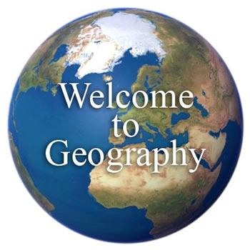
2.) If you were to become a geographer in your career, what kind of work do you think you would be doing? Before you begin writing, turn that same classmate and exchange ideas. Describe this work in one to two sentences.

__________________________________________________________________________________________________________________________________________________________________________________________________________________

3.) List five reasons that various people in the movie say is the reason they love geography.

1.)
2.)
3.)
4.)
5.)

4.) The Royal Geographic Society is based in which country, and in what city is it located?

5.) Alistair was studying in Borneo, what was he doing there?

__________________________________________________________________________________________________________________________________________________________________________________________________________________

6.) Tori James is a geographer, what did geography inspire her to do?

7.) Geography is listed as one of the top five degrees that employers look for in England. Why do you think businesses would hire a geographer?

8.) Laura Fry is a mapper, or cartographer, employed by a charity in England. What topic does she map?

9.) Ben Saunders says that geography inspires students to explore the world outside their own neighborhood. What area did Ben Saunders explore himself?

